Order Of Lenten Service

Opening Hymn: TLH 142

Reading: Lent VI

The History of the Passion of our Lord

Sermon Hymn: TLH 143 vs 1-8

Sermon Text: Luke 12:49 -53

Cause Of Division

Confession of Sins: O almighty God, merciful Father, I, a poor miserable sinner, confess unto Thee all my sins and iniquities, with which I have ever offended Thee and justly deserved Thy temporal and eternal punishment. But I am heartily sorry for them and sincerely repent of them, and I pray Thee of Thy boundless mercy and for the sake of the holy, innocent, bitter sufferings and death of Thy beloved Son, Jesus Christ, to be gracious and merciful to me, a poor, sinful being.

Holy Communion

The Lord's Prayer

The Blessing

Closing Hymn: TLH 143 vs 9-15

* * * * * * * * * * * * *

Koinonia Hour

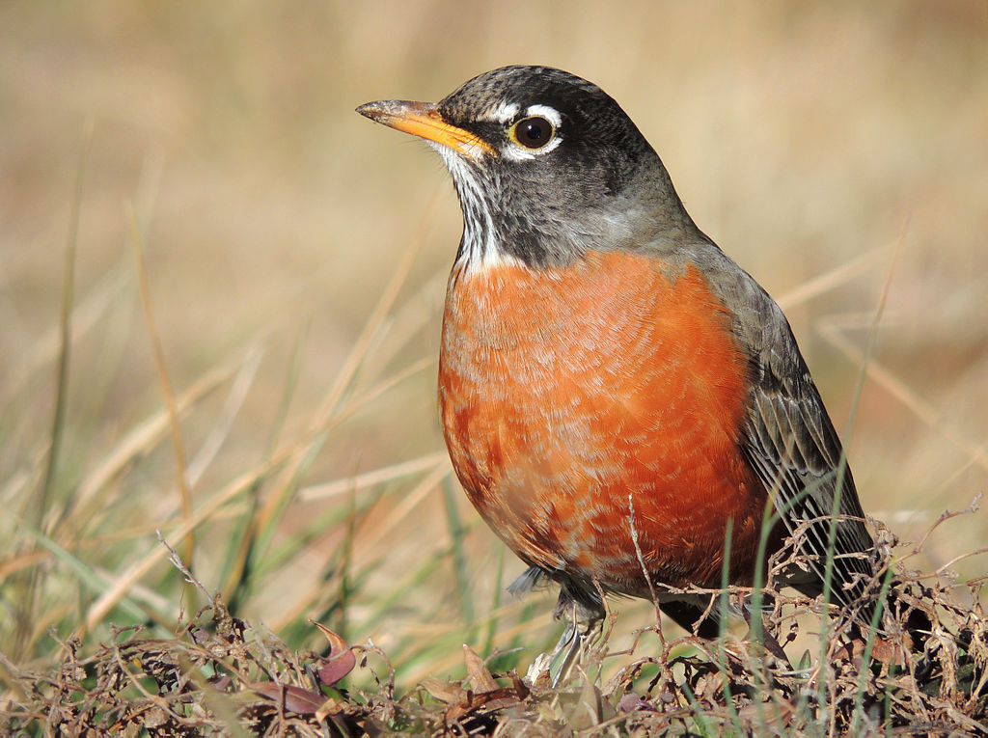

Sure Sign Of Spring

Water
Of
Life

3 April 2022

W A T E R O F L I F E

Independent Christian Church—Conservative Lutheran Doctrine

Worship Service: 9:30 a.m. Bible Study: 10:45 a.m.

Larry Cooper, Pastor E-Mail address:
111 N. Ridge Road lcooper@wateroflife.cc
Coon Valley, WI 54623 Web Site:
www.wateroflife.cc

* * * * * * * * * * * * * * * * * * * * * * * * * * *

Sermon Text: Luke 12:49-53

Cause Of Division

* * * * * * * * * * * * * * * * * * * * * * * * * * *
49 I am come to send fire on the earth; and what will I, if it be already kindled?
50 But I have a baptism to be baptized with; and how am I straitened till it be accomplished!
51 Suppose ye that I am come to give peace on earth? I tell you, Nay; but rather division:
52 For from henceforth there shall be five in one house divided, three against two, and two against three.
53 The father shall be divided against the son, and the son against the father; the mother against the daughter, and the daughter against the mother; the mother in law against her daughter in law, and the daughter in law against her mother in law.

